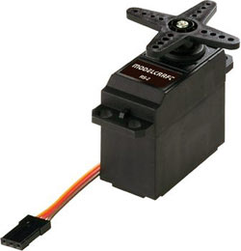

Modelcraft RS-2 Servo

**Basic Information**

|  |  |
| --- | --- |
| Modulation: | Analog |
| Torque: | **4.8V:**   45.3 oz-in (3.26 kg-cm)  **6.0V:**   49.6 oz-in (3.57 kg-cm) |
| Speed: | **4.8V:**   0.19 sec/60°  **6.0V:**   0.17 sec/60° |
| Weight: | 1.38 oz (39.2 g) |
| Dimensions: | Length:  1.61 in (41.0 mm)  Width:  0.79 in (20.0 mm)  Height:  1.65 in (42.0 mm) |
| Motor Type: | ? ([add](http://www.servodatabase.com/add-data?make=modelcraft&model=rs-2" \o "Add missing data to Modelcraft RS-2)) |
| Gear Type: | Plastic |
| Rotation/Support: | Bushing |

**Additional Specifications**

|  |  |
| --- | --- |
| Rotational Range: | **203°** |
| Pulse Cycle: | **20 ms** |
| Pulse Width: | **540-2470 µs** |
| Connector Type: | **JR** |